e.)

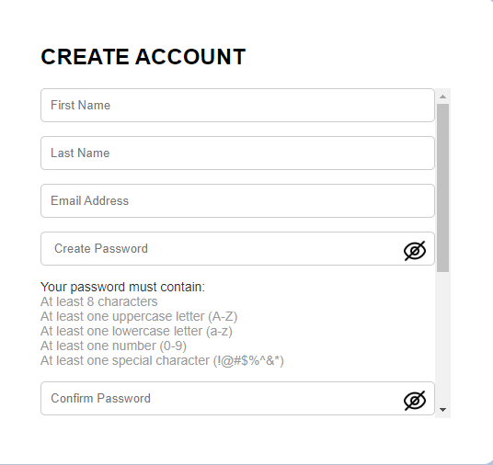

body {

    background-color: #b0c4de;

    display: flex;

    justify-content: center;

    align-items: center;

    min-height: 100vh;

    margin: 0;

}

.toggle-password {

    cursor: pointer;

    position: absolute;

    right: 10px; /* Adjust position from the right */

    top: 40%;

    transform: translateY(-50%); /* Center vertically */

    width: 24px; /* Set the width for your icons */

    height: 24px; /* Set the height for your icons */

}

.guidelines {

    font-size: 14px;

    color: #333;

    margin-bottom: 10px;

}

.strength {

    font-weight: bold;

    margin-top: 5px;

}

.weak {

    color: red;

}

.medium {

    color: orange;

}

.strong {

    color: green;

}

|  |  |
| --- | --- |
| Test Case | Steps |
| 1.1 Server Performance Testing | |
| Test Case 1: **Behaviour of the system under stress** | This is going to be done using tools like Apache JMeter to check the behaviour of the system under stress. |
| Test Case 2: **CPU and Memory Usage** | We are going to monitor CPU and memory usage on the web server during peak traffic periods to ensure that system resources are adequate to handle the expected load. Tools like **Prometheus** and **Grafana** are going to be used track real-time performance. |
| 1.2 Storage and Database Performance Testing | |
| Test Case 1: | Disk I/O test: Check the input/output performance of the disk to ensure fast retrieval and storage of data, which is especially important for database queries. Iometer was used for disk performance benchmark testing. |
| Test Case 2: | Database stress testing: We simulated multiple simultaneous users accessing the VAHSA database to ensure the database can handle a large number of read/write operations without degrading performance. Tools such as HammerDB were used for this process. |